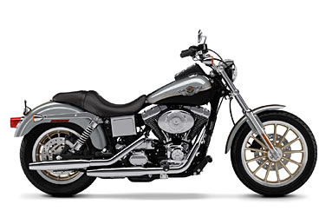
Participant Registration Form
The Mount Kisco Lions Club
4th Annual * Guiding Eyes
Charity Motorcycle Ride
Sunday, July 26, 2015
Arrive 8:00- 9:30 AM
At Mt. Kisco Village Hall
104 Main St. (next to Library)
Free Coffee & Donuts !
Kickstands up at 10 AM !

Please fill out the information below to Pre-Register
Don’t Delay! FREE TEE SHIRT only to the 1st 25 riders who pre register!
RIDER PASSENGER
Name_________________________________ Name _________________________________
Address_______________________________ Address _______________________________
Town, State, Zip________________________ Town, State, Zip__________________________
Phone ________________________________ Phone __________________________________
e-mail ________________________________ e-mail__________________________________
Make of Motorcycle ______________ Year _________Color________ Plate #______________
Motorcycle and Rider only $25 Donation -or- Rider and Passenger $40 Donation (check one)
Donation Includes 1 free T shirt, Bar-b-que, door prizes, a free raffle, music, contests and more!
Non riders may attend Bar-B-Que held at the Boys& Girls Club for a donation of only $15.
Liability Waiver: I hereby release and agree to hold harmless, The Mt. Kisco Lions Club, The Guiding Eyes for the Blind, The Boys and Girls Club of Mt. Kisco, the directors, sponsors, representatives, officers, members, agents, employees, volunteers or others of them all, of any and all liability, loss, claims and demands that may occur from any loss, damage, injury or death in any way resulting from or arising in connection with this event and weather arising while engaged in competition, practice or preparation therefore or while entering or departing from premises where this event in held from any cause whatsoever. I am aware of the inherent risk and danger associated with the operation of a motorcycle and do so of my own free will and with my best judgment. I attest that I hold a valid license to operate a motorcycle and maintain it in a safe condition applicable to the laws of my State. I have a valid liability insurance policy as required by law.
Signature (rider) ________________________Signature (passenger)______________________
Total donation from above: (rider or both ) $ _______
Non Riders for Bar-B-Que ( ) x 15ea. $ _______
Extra Event Tee Shirts ( ) x $ 20 ea. $ _______
(circle size) S M L XL or 2X
Total Amount Enclosed $ _______
MAIL THIS FORM WITH YOUR CHECK OR MONEY ORDER PAYABLE TO:
Mount Kisco Lions Club P.O. Box 187 Mt. Kisco, NY 10549
For more information visit our website @ www.mountkiscolionsclub.org. or call Bob: 760-0014

